Konteks Payload
Payload yang diberikan merupakan hasil modifikasi dari API yang seharusnya tetapi masih merepresentasikan struktur aslinya.

Nantinya kelompok capstone hanya perlu memerhatikan dua section yaitu sumber dan output penilaian.

- Sumber
Kelompok perlu menilai 5 video yang terdapat pada section berikut.
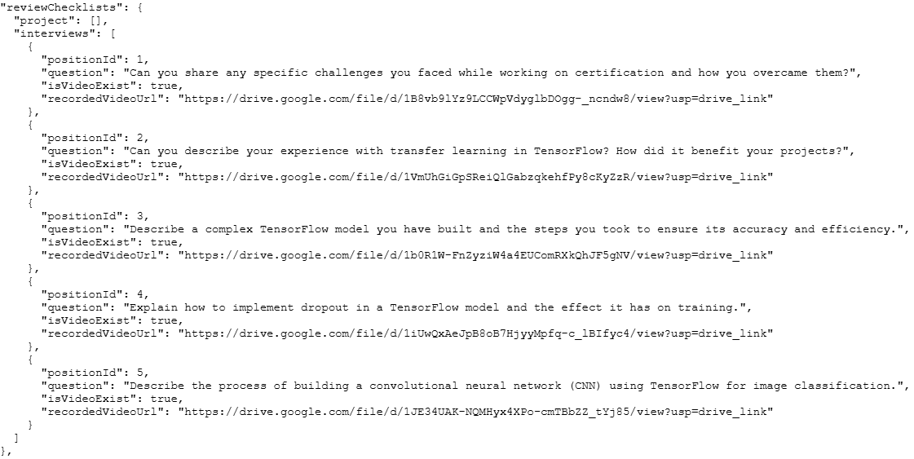
Masing-masing video memiliki basis rubrik penilaiannya sebelum diberikan ke assesor sebagai final decision. Nantinya, penilaian yang dibuat oleh tim capstone dapat mengacu ke aspek beriktu ini
No | Soal | 4 | 3 | 2 | 1 | 0
1 | Can you share any specific challenges you faced while working on certification and how you overcame them? | Comprehensive and Clear Response | Specific Challenge with Basic Solution | General Challenge Mentioned without Details | Minimal or Vague Response | Unanswered
1 |  | Provides a detailed description of specific challenges encountered during the certification. | Describes at least one specific challenge related to building machine learning models with TensorFlow. | General Challenge Mentioned without Details | Minimal or Vague Response | Unanswered
1 |  | Offers clear explanations of how each challenge was overcome. | Provides a basic explanation of how the challenge was overcome. | General Challenge Mentioned without Details | Minimal or Vague Response | Unanswered
1 |  | Demonstrates strong understanding of technical aspects and problem-solving skills. | Explanation may be brief or lack depth. | General Challenge Mentioned without Details | Minimal or Vague Response | Unanswered
1 |  | Response is very clear, well-organized, and reflects on the learning process. | Shows some understanding but lacks detailed insight. | General Challenge Mentioned without Details | Minimal or Vague Response | Unanswered
2 | Can you describe your experience with transfer learning in TensorFlow? How did it benefit your projects? | Comprehensive and Very Clear Response. | Specific Experience with Basic Explanation. | General Response with Limited Details. | Minimal or Vague Response | Unanswered
2 |  | Offers a detailed description of personal experience using transfer learning in TensorFlow. | Describes personal experience with transfer learning in TensorFlow. | Mentions transfer learning or TensorFlow in general terms. | Minimal or Vague Response | Unanswered
2 |  | Provides specific examples of projects and clearly explains the benefits gained. | Provides examples of projects where transfer learning was applied. | Provides minimal details about personal experience. | Minimal or Vague Response | Unanswered
2 |  | Demonstrates strong understanding of transfer learning concepts and their practical application. | Explains how transfer learning benefited those projects. | Does not clearly explain how transfer learning benefited projects. | Minimal or Vague Response | Unanswered
2 |  | Response is very clear, well-organized, and reflects deep engagement with the subject. | Explanation may be brief or lack comprehensive insight. | Shows basic understanding but lacks depth and specificity. | Minimal or Vague Response | Unanswered
3 | Describe a complex TensorFlow model you have built and the steps you took to ensure its accuracy and efficiency. | Comprehensive and Very Clear Response. | Specific Model with Basic Explanation. | General Response with Limited Details | Minimal or Vague Response | Unanswered
3 |  | Offers a detailed description of a complex TensorFlow model built. | Describes a complex TensorFlow model they have built. | Mentions building a TensorFlow model in general terms. | Minimal or Vague Response | Unanswered
3 |  | Provides specific details about the model's architecture, features, and purpose. | Provides some details about the model's architecture or purpose. | Provides minimal details about the model's complexity. | Minimal or Vague Response | Unanswered
3 |  | Clearly explains the steps taken to ensure both accuracy and efficiency, such as data preprocessing, model optimization techniques, regularization methods, and performance tuning. | Explains steps taken to ensure accuracy and efficiency, but may lack depth. | Does not clearly explain the steps taken to ensure accuracy and efficiency. | Minimal or Vague Response | Unanswered
3 |  | Demonstrates strong understanding of TensorFlow and machine learning concepts. | Explanation may be brief or not fully comprehensive. | Shows basic understanding but lacks depth and specificity. | Minimal or Vague Response | Unanswered
3 |  | Response is very clear, well-organized, and reflects deep engagement with the subject.
4 | Explain how to implement dropout in a TensorFlow model and the effect it has on training. | Comprehensive and Very Clear Response. | Specific Explanation with Basic Understanding. | General Response with Limited Details | Minimal or Vague Response | Unanswered
4 |  | Provides a detailed explanation of how to implement dropout in a TensorFlow model, including code examples or specific functions (e.g., using tf.keras.layers.Dropout). | Explains how to implement dropout in a TensorFlow model with some specifics (e.g., mentions using Dropout layer). | General Response with Limited Details | Minimal or Vague Response | Unanswered
4 |  | Clearly explains the effect of dropout on training, such as how it helps prevent overfitting by randomly deactivating neurons during training. | Describes the general effect of dropout on training, such as preventing overfitting. | General Response with Limited Details | Minimal or Vague Response | Unanswered
4 |  | Discusses the impact on model performance, generalization, and possibly mentions considerations like dropout rates. | May omit some details about implementation or effects. | General Response with Limited Details | Minimal or Vague Response | Unanswered
4 |  | Demonstrates strong understanding of TensorFlow and machine learning concepts. | Demonstrates a reasonable understanding but lacks comprehensive insight. | General Response with Limited Details | Minimal or Vague Response | Unanswered
4 |  | Response is very clear, well-organized, and reflects deep engagement with the subject.
5 | Describe the process of building a convolutional neural network (CNN) using TensorFlow for image classification. | Comprehensive and Very Clear Response | Specific Explanation with Basic Understanding | General Response with Limited Details | Minimal or Vague Response | Unanswered
5 |  | Provides a detailed, step-by-step description of building a CNN in TensorFlow for image classification. | Describes the process of building a CNN in TensorFlow with some specifics. | General Response with Limited Details | Minimal or Vague Response | Unanswered
5 |  | Covers all key components, including data loading and preprocessing, defining the CNN layers (convolutional, pooling, activation functions), compiling the model with appropriate loss function and optimizer, training the model, and evaluating performance. | Includes key steps such as data preprocessing, defining the CNN architecture, compiling the model, and training. | General Response with Limited Details | Minimal or Vague Response | Unanswered
5 |  | May include code examples or specific TensorFlow functions used. | May lack comprehensive detail or omit some important aspects. | General Response with Limited Details | Minimal or Vague Response | Unanswered
5 |  | Demonstrates strong understanding of CNNs and TensorFlow. | Demonstrates reasonable understanding but may not fully elaborate on each step. | General Response with Limited Details | Minimal or Vague Response | Unanswered
5 |  | Response is very clear, well-organized, and reflects deep engagement with the subject.

- Output Penilaian
Output yang diharapkan dari proses penilaian merupakan json dengan struktur seperti berikut
{
"assessorProfile": {
"id": 47,
"name": "xxx",
"photoUrl": "xxx"
},
"decision": "Need Human",
"reviewedAt": "2025-08-06 21:19:05",
"scoresOverview": {
"project": 100,
"interview": 80, → Jumlah dari score interviews
"total": 94.3
},
"reviewChecklistResult": {
"project": [],
"interviews": {
"minScore": 0,
"maxScore": 4,
"scores": [
{
"id": 1,
"score": 3,
"reason": Str
},
{
"id": 2,
"score": 3,
"reason": Str
},
{
"id": 3,
"score": 4,
"reason": Str
},
{
"id": 4,
"score": 3,
"reason": Str
},
{
"id": 5,
"score": 3,
"reason": Str
}
]
}
},
"Overall notes": "lancar tidak mencurigakan"
}

